U.S. Radiocommunications Sector
Fact Sheet
Working Party: USWP7C | Document No: USWP7C/27-028NC
Reference:  R23-WP7C-C-0041!N01  WRC-27 AI 1.17 | Date: 12 August 2024
Document Title: NON-CONSENSUS- Working document towards a preliminary draft new Recommendation ITU-R RS.[RXSW_PROTECT_CRITERIA]
Author(s)/Contributors(s):  Philip Sohn  DOC/NOAA/NWS  Tomasz Wojtaszek  DOC/NOAA  Christopher Hough  DOC/NOAA  Edna Prado  DOC/NOAA | Phone: 301-427-9676  Email: philip.sohn@noaa.gov  Phone : 301-456-4574  Email : tomasz.wojtaszek@noaa.gov  Phone : 301-323-8212  Email : christopher.hough@noaa.gov  Phone : 301-628-5742  Email : edna.prado@noaa.gov
Purpose/Objective: To propose updates to the working document towards a preliminary draft new Recommendation for protection criteria of receive-only space weather sensors in the meteorological aids service (space weather).
Abstract:
The meeting of Working Party 7C (18-22 March 2024) agreed to develop a preliminary draft new Recommendation on the protection criteria of receive-only space weather sensors based on the working document towards a preliminary draft new Report ITU-R RS.[RXSW_INTERF_CRITERIA] which was carried over from the previous study period (2019-2023). The meeting also agreed to limit the scope of this document to space weather receive-only systems operating in the frequency bands listed in the WRC-27 AI 1.17. This contribution provides editorial updates to the initial version of the WD-PDN Recommendation in support of progressing the work of the WRC-27 Agenda Item 1.17.

Non-Consensus Status: Agreement was not reached at the last prep meeting due to a request to add some notes to the document indicating the need for additional review and work, and questions were raised regarding the need to include much of the text in Section 2. Progress has been made since the last prep meeting on notes to be inserted however the disposition of Section 2 still needs to be resolved. Therefore this version is the version considered at the last prep meeting.
Fact Sheet Preparer: Philip Sohn

Radiocommunication Study Groups | 
Source: R23-WP7C-C-0041!N01  Subject: WRC-27 agenda item 1.17 | Document 7C/41-E
 | XX September 2024
 | English only
United States of America
PROPOSED UPDATES TO THE WORKING DOCUMENT TOWARDS A PRELIMINARY DRAFT NEW RECOMMENDATION ITU-R RS.[RXSW_PROTECT_CRITERIA]
Protection criteria of receive-only space weather sensors
in the meteorological aids service (space weather)
Introduction
This contribution provides editorial updates to the WD-PDN Recommendation RS.[RXSW_PROTECT_CRITERIA] that was attached as Annex 1 to the report on the meeting of working party 7C (18-22 March 2024).
Attachment: 1

attachment
working document towardS a PRELIMINARY DRAFT new recommendation ITU-R RS.[RXSW_protect_CRITERIA]
Protection criteria of receive-only space weather sensors
in the meteorological aids service (space weather)
(20xx)
Scope
This Recommendation provides protection criteria which should be used for sharing and compatibility studies for receive-only space weather sensors operating in the meteorological aids service (space weather), abbreviated as MetAids (space weather).
Related ITU-R Recommendations and Reports
Report ITU-R RS.2456-1 – Space weather sensor systems using radio spectrum
Keywords
meteorological aids service, MetAids, space weather, receive-only space weather sensor
Abbreviations/Glossary
MetAids: Meteorological aids service
The ITU Radiocommunication Assembly,
considering
a) that Radio Regulations (RR) Article 29B and Resolution 675 (WRC-23) allow space weather sensors to operate under the meteorological aids service in the subset MetAids (space weather) allocations;
b) that it is necessary to specify the maximum allowable interference into receive-only space weather sensors operating in the MetAids (space weather) to ensure that those sensors can achieve adequate performance in the presence of interference;
c) that WRC-27 agenda item 1.17 proposes to consider regulatory provisions for receive-only space weather sensors and their protection in the Radio Regulations, taking into account the results of ITU Radiocommunication Sector studies, in accordance with Resolution 682 (WRC-23),
recommends
that the protection criteria given in Annex 1 should be used for sharing and compatibility studies for receive-only space weather sensors operating in the MetAids (space weather).

Annex 1
Protection criteria of receive-only space weather sensors
in the meteorological aids service (space weather)
{Editor’s note: Furthermore significant revision of this working document is needed in order to limit the scope of this document to MetAids(space weather) receive-only system operating in the frequency bands under study in WRC-27 AI 1.17.}

1 Introduction
TBD

2 Riometers
A riometer is an instrument used to measure the relative opacity of the ionosphere by making precise measurements of the power of the cosmic radio noise radiated from celestial bodies or galactic sources. In light of the nature of these measurements, the protection criteria of riometers are determined based on the methodology given in Recommendation ITU-R RA.769-2 – Protection criteria used for radio astronomical measurements. The minimum antenna noise temperatures used to calculate the interference level for the radiometer have been estimated from those listed in Table 1 of Recommendation ITU-R RA.769-2 using linear interpolation. The integration time is employed to be of 1 sec, which is considered typical for riometer observation. For bandwidth, 250 kHz is assumed.
Table 1 below provides the protection criteria for the typical operational frequencies identified in Report ITU-R RS.2456-1 and also contained in Resolution 682 (WRC-23) as the potential frequency bands for the MetAids (space weather) allocation.
Table 1
Riometer protection criteria for typical operational frequencies
Frequency band  (MHz) | Frequency  fc  (MHz) | Bandwidth  Δf  (MHz) | Minimum antenna noise temperature  T_{A}  (K) | Receiver noise temperature  T_{R}  (K) | System sensitivity |  | Protection criteria
 |  |  |  |  | Temperature  ΔT  (mK) | Power spectral density  ΔP  (dB(W/Hz)) | Input power  ΔP_{H}  (dBW) | pfd  S_{H} Δf  (dB(W/m²)) | Spectral pfd  S_{H}  (dB(W/(m² · Hz)))
27.5-28.0 | 27.8 | 0.25 | 9400 | 200 | 19200 | ‒216 | ‒172 | ‒181 | ‒235
29.7-30.2 | 30.0 | 0.25 | 7900 | 200 | 16200 | ‒217 | ‒173 | ‒181 | ‒235
32.2-32.6 | 32.4 | 0.25 | 6700 | 200 | 13800 | ‒217 | ‒173 | ‒182 | ‒235
37.5-38.325 | 38.2 | 0.25 | 4600 | 200 | 9600 | ‒219 | ‒175 | ‒182 | ‒236
73.0-74.6 | 74.0 | 0.25 | 1000 | 200 | 2400 | ‒225 | ‒181 | ‒182 | ‒236

3 Solar flux monitors
Single-frequency solar radio flux measurements can be used to observe flares and eruptive processes and assess the overall level of solar activity on different time scales. In the following, single-frequency solar flux measurements are understood as single-dish measurements of the spatially integrated (over the solar disc or the extent of the solar corona) solar brightness. It is a power spectral flux density expressed in terms of Solar Flux Unit (1 SFU = 10⁻²² W/(m² ‧ Hz)). Measurements are typically made from local sunrise to sunset at a temporal resolution that varies from one observatory to the other. As an illustration, Radio Solar Telescope Network (RSTN) flux monitors provide 1-s resolution light curves. These observations are interrupted once or more times a day to perform calibration and estimations of the non-solar components to the signal. This is done by moving the telescope to a position along the apparent solar trajectory where the Sun has been or will be, and take measurements of the sky and possible ground contribution. Astronomical radio sources (for example the Cygnus-A radio galaxy) are often used as noise calibrators during these offset measurements. Calibration requires sensitivity and bands without interference such as is the case in the RAS bands. The protection criteria for solar flux monitors operating outside radio astronomy band could be established based on the minimum measurable solar flux value for a given frequency, not the receiver noise floor, which is typically lower. Report ITU-R RS.2456-1 indicates that protection criteria for solar flux monitors is determined using the following formula:
I_{max (pfd)} = SolarRadioFlux_{min} × Bandwidth × Precision (1)
where:
Imax (pfd) = maximum acceptable interference power flux density (W/m²)
SolarRadioFlux_{min} = typical solar radio flux observed at solar minimum also indicated as quiet Sun (W/(m² Hz))
Bandwidth = bandwidth of the receiver (Hz)
Precision = precision of the measurement, up to 3 decimal positions. In general, a precision of 1% is required for the quiet Sun radio-astronomical observations (equivalent to 2 decimal position or –20 dB).
Table 5 in Report ITU-R RS.2456-1 provides the characteristics of a variety of solar flux monitors operated around the globe, providing data of space weather predictions and warnings. The typical solar radio flux at solar minimum can be based on data presented in Fig. 6 of Report ITU-R RS.2456-1, which is also replicated below in Figure 1.
Figure 1
Typical minimum solar flux levels
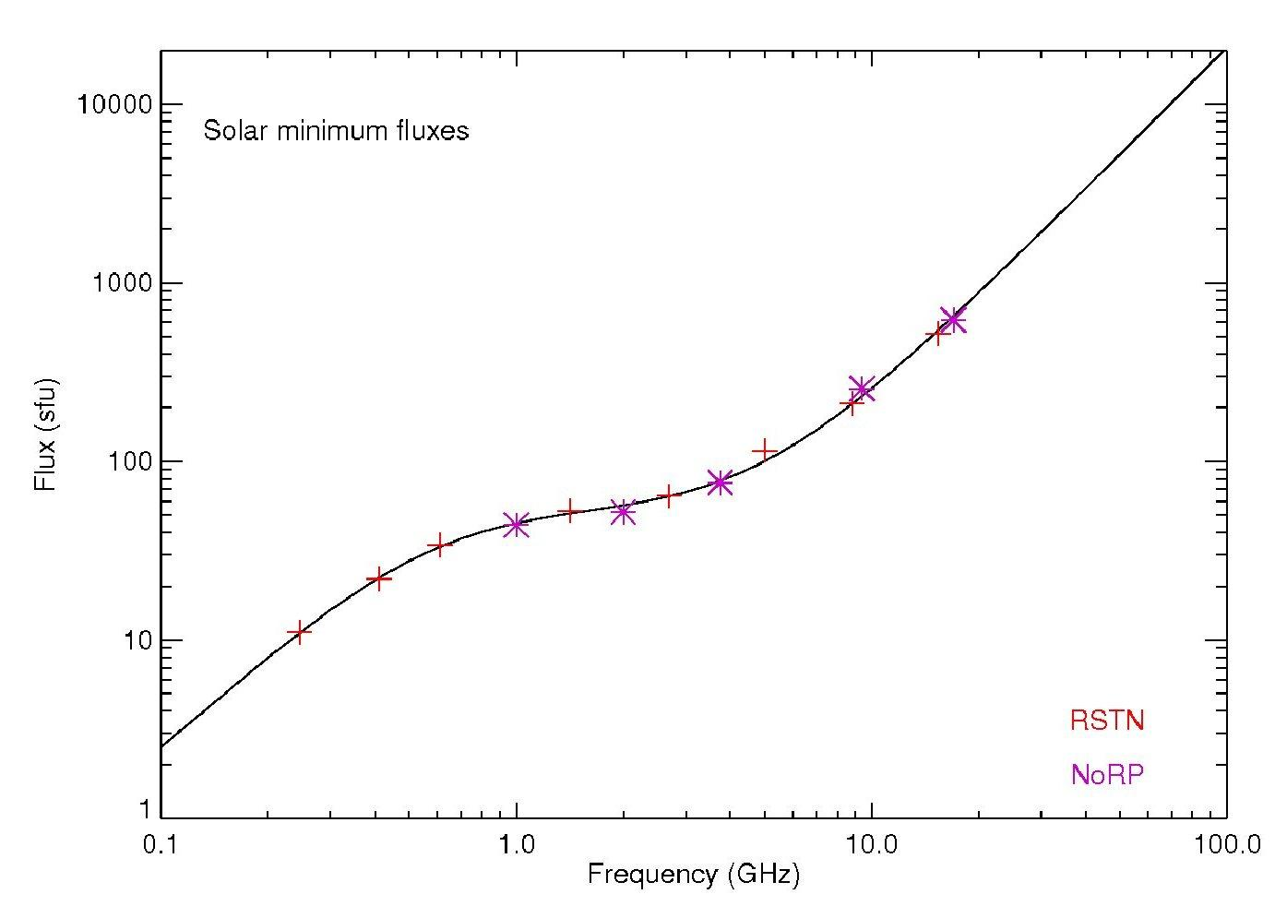
Table 2 presents values from Figure 1 for frequencies that are used by solar radio flux monitors identified in Report ITU-R RS.2456-1.
Table 2
Minimum Solar Flux Levels for Solar Flux Monitor Operational Frequencies
Frequency  (MHz) | Minimum solar flux  (SFU) | Minimum solar flux  (W/(Hz m²))
140 | 4.5 | 4.5 × 10⁻²²
150 | 5.0 | 5.0 × 10⁻²²
236 | 10.1 | 10.1 × 10⁻²²
245 | 11 | 11 × 10⁻²²
327 | 18 | 18 × 10⁻²²
410 | 21 | 21 × 10⁻²²
432 | 22 | 22 × 10⁻²²
610 | 32 | 32 × 10⁻²²
1 000 | 43 | 43 × 10⁻²²
1 415 | 50 | 50 × 10⁻²²
1 665 | 51 | 51 × 10⁻²²
2 000 | 58 | 58 × 10⁻²²
2 695 | 61 | 61 × 10⁻²²
2 800 | 62 | 62 × 10⁻²²
3 300 | 70 | 70 × 10⁻²²
3 760 | 74 | 74 × 10⁻²²
4 541 | 90 | 90 × 10⁻²²
4 995 | 98 | 98 × 10⁻²²
8 325 | 190 | 190 × 10⁻²²
8 800 | 205 | 205 × 10⁻²²
9 084 | 220 | 220 × 10⁻²²
10 650 | 505 | 505 × 10⁻²²
15 400 | 600 | 600 × 10⁻²²

Equation 1 above provides the maximum interference level in terms of a power flux density. Taking the antenna into account, the maximum interference threshold becomes:
I_{max} = I_{max (pfd)} × A_{e} (2)
where:
I_{max} = maximum acceptable interference level (W)
I_{max (pfd)} = maximum acceptable interference power flux density (W/m²)
A_{e} = antenna effective aperture (m²).
Antenna effective aperture is calculated with the following equation:
A_{e} = G λ² / 4π (3)
where:
A_{e} = antenna effective aperture (m²)
G = antenna gain
λ = wavelength for frequency of operation (m).
Since protection criteria is dependent upon antenna effective aperture, the values for each system will be different. Table 3 provides the protection criteria for each space weather sensor location, which are dependent on system antenna gain and frequencies of operation of each individual location.
It should be noted that the maximum acceptable interference level I_{max} provided in equation (2) is calculated on the assumption that the interference is received through the antenna sidelobes of the solar flux monitor. However, there are some other cases of interference coming into or near the antenna main beam direction. For example, the geostationary-satellite orbit overlaps the apparent solar direction in spring and autumn, which lead to significant interference from the geostationary satellites. In these cases, the calculation for protection criteria should take into account the antenna gain level in the direction of arrival of the interference.
An option for the calculation of the protection criteria in all the bands is to use the methodology of the Recommendation ITU-R RA.769, and to choose the specific parameter for the system temperature (addition of the antenna temperature and receiver temperature) and integration time that lead to the required values.
Table 3
Solar flux monitor protection criteria for RSTN-RIMS receiving system parameters
with a precision of 1% or 2 digit

Site name | Latitude | Longitude | Frequency  (MHz) | Antenna  gain (dBi) | Receive BW  (MHz) | Effective aperture  (m²) | Protection criteria¹  dB(W/(m²∙MHz)) | Comment
Learmonth (SEON)  San Vito (SEON)  Sagamore Hill (SEON)  Palehua (SEON) | 22.2°S  40.6°N  42.4°N  21.4°N | 114.1°E  17.8°E  70.8°W  158.1°W
 |  |  | 610 | 32.5 | 6 | 34.23 | -164.8
¹ Power flux density at the antenna.

4 Spectrometers
Solar spectrometers measure radio emission levels from the sun across much wider bandwidths in comparison to solar flux monitors. The methodology for calculating protection criteria is the same as that used for solar flux monitors, however the frequencies and bandwidths will differ from solar flux monitors. The minimum solar flux levels shown in Figure 1 apply.
An option for the calculation of the protection criteria in all the bands is to use the methodology of the Recommendation ITU-R RA.769, and to choose the specific parameter for the system temperature (addition of the Antenna temp. and Receiver temp.) and integration time that lead to the required values.
Editor’s note: Minimum solar flux levels below 100 MHz are required to complete this section.
Table 4 presents an equation for estimating the minimum solar flux levels for continuous frequency ranges. Since spectrometers operate over broad frequency ranges, calculation of protection criteria at discrete operating frequencies is not practical.
Table 4
Equations for minimum solar flux for frequencies between 10 MHz and 18 GHz
Frequency range  (MHz) | Minimum solar flux equation  (W/(m² · Hz)) | Values for SL and IP
10-30 | ${SolarFlux}_{min}$ $= \left({10}^{\left(\left(SL *loglog \left(f\right) \right)+ IP\right)}\right)* {10}^{-22}$  where f is the observation frequency in MHz | [TBD]
30-100 |  | SL = 1.992; IP=-3.7122
100-315 |  | SL = 1.556; IP = −2.686
315-694 |  | SL = 1.058; IP = −1.441
694-3 600 |  | SL = 0.418; IP = 0.379
3 600-7 900 |  | SL= 1.006; IP = −1.727
7 900-18 000 |  | SL = 1.870; IP = −5.053

Table 5
Equations for calculating solar spectrometer protection criteria for frequencies
between 10 MHz and 18 GHz
Frequency range  (MHz) | Equation for protection criteria  (dBW) | Values for SL and IP
10-30 | $I_{max}$ $=10*loglog \left(G\frac{λ2}{4π} ×{SolarFlux}_{min} × BW × P\right)$  where:  ${SolarFlux}_{min}$ $= \left({10}^{\left(\left(SL *loglog \left(f\right) \right)+ IP\right)}\right)* {10}^{-22}$  f is observation frequency in MHz  G is sensor antenna gain  BW is sensor bandwidth  P is required precision. | [TBD]
30-100 |  | SL = 1.992; IP=-3.7122
100-315 |  | SL = 1.556; IP = −2.686
315-694 |  | SL = 1.058; IP = −1.441
694-3 600 |  | SL = 0.418; IP = 0.379
3 600-7 900 |  | SL= 1.006; IP = −1.727
7 900-18 000 |  | SL = 1.870; IP = −5.053

5 IPS
{To be filled}

6 Summary
The information in this document can be used for future sharing and compatibility studies with solar flux monitor sensors and solar spectrometer sensors [and interplanetary scintillation sensors], as appropriate. The system sensitivity based on the minimum measurable solar level, combined with the sensor measurement resolution, is above the receiver noise level. For both system types the protection criteria is established using the minimum RF levels produced by the sun, rather than the sensor receiver noise level.

